Lab 6

Histogram Equalization

**Introduction**

In this lab you will try to improve the contrast of an image by doing histogram equalization.

Consider the example below.

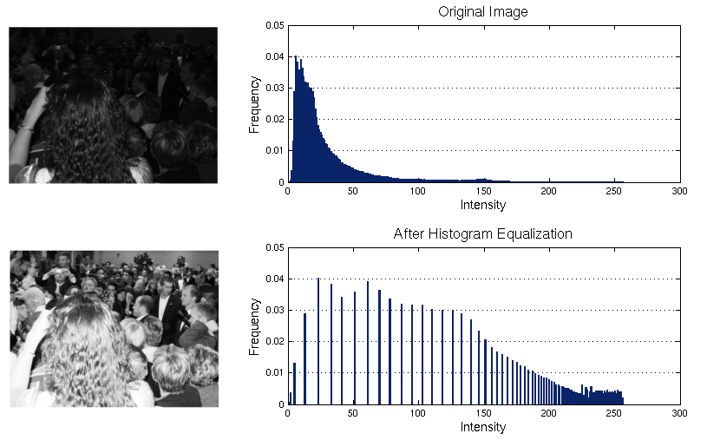

**Tools/Software Requirement**

Python 3.X

**Description**

1. Write a program that shows the histogram for a given image. For displaying the histogram, you may use Matplotlib. The following link might be helpful in this regard. <https://bespokeblog.wordpress.com/2011/07/11/basic-data-plotting-with-matplotlib-part-3-histograms/>
2. Write a program that equalizes the histogram of a given image. Consider the formula,

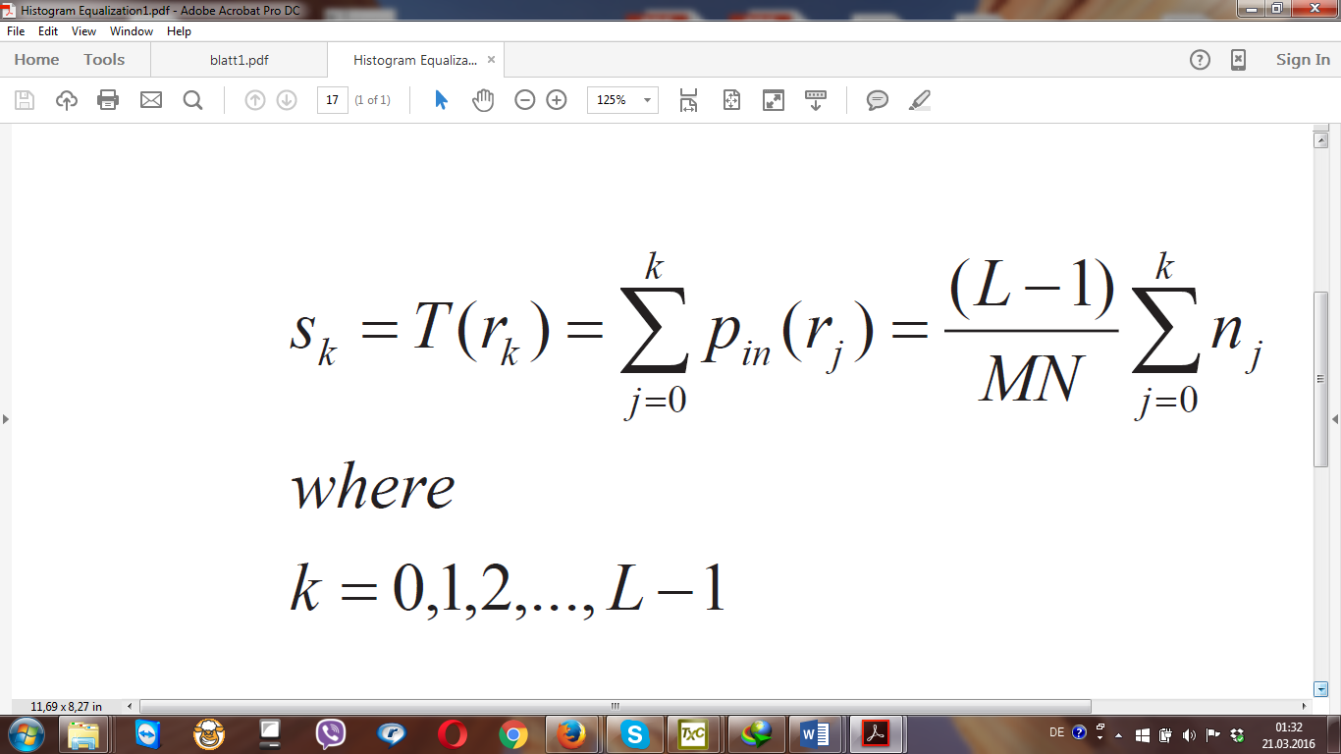

c) Show the histograms before and after equalization. Again consult Matplotlib. Opencv can also be used for some parts.

d) Does the equalized histogram has a uniform distribution?

**Some important points about the exercise.**

1. You should apply histogram equalization on Greyscale image (given in lab folder).  
2. You should not use the builtin histogram equalization method available in matplotlib or opencv. You can use these packages only for displaying histograms.  
3. You should implement the formula mentioned in the exercise sheet to implement histogram equalization.

**Deliverable**

Please upload the report with code and screenshots of output.